GEOPETPLUS
JNDI Database Connection Guide

File History:
S.No | Document Name | Version | Created By | Created Date | Modified By | Modified Date
1 | GeoPetPlus JNDI Database Guide-v1.0.doc | v1.0 | Nagarjuna Goud Tummala | 03/13/2016

Step#:
- Goto geopetplusadmin project
- Open spring-database.xml file
- Update below database connection settings for geopetplus web application
<!-- Normal Database Connection -->
<!-- Use this for JUnits testcases and comment the JNDI database connection -->
<!—
<bean id="dataSource" class="org.springframework.jdbc.datasource.DriverManagerDataSource">
<property name="driverClassName" value="${db.driver}" />
<property name="url" value="${db.url}" />
<property name="username" value="${db.username}" />
<property name="password" value="${db.password}" />
</bean>
-->

<!-- JNDI Database Connection -->
<bean id="dataSource" class="org.springframework.jndi.JndiObjectFactoryBean">
<property name="jndiName" value="${jndi.db.url}"/>
</bean>

- Update below database connection settings for JUNIT testing
<!-- Normal Database Connection -->
<!-- Use this for JUnits testcases and comment the JNDI database connection -->
<bean id="dataSource" class="org.springframework.jdbc.datasource.DriverManagerDataSource">
<property name="driverClassName" value="${db.driver}" />
<property name="url" value="${db.url}" />
<property name="username" value="${db.username}" />
<property name="password" value="${db.password}" />
</bean>

<!-- JNDI Database Connection -->
<!--
<bean id="dataSource" class="org.springframework.jndi.JndiObjectFactoryBean">
<property name="jndiName" value="${jndi.db.url}"/>
</bean>
-->

Step#:
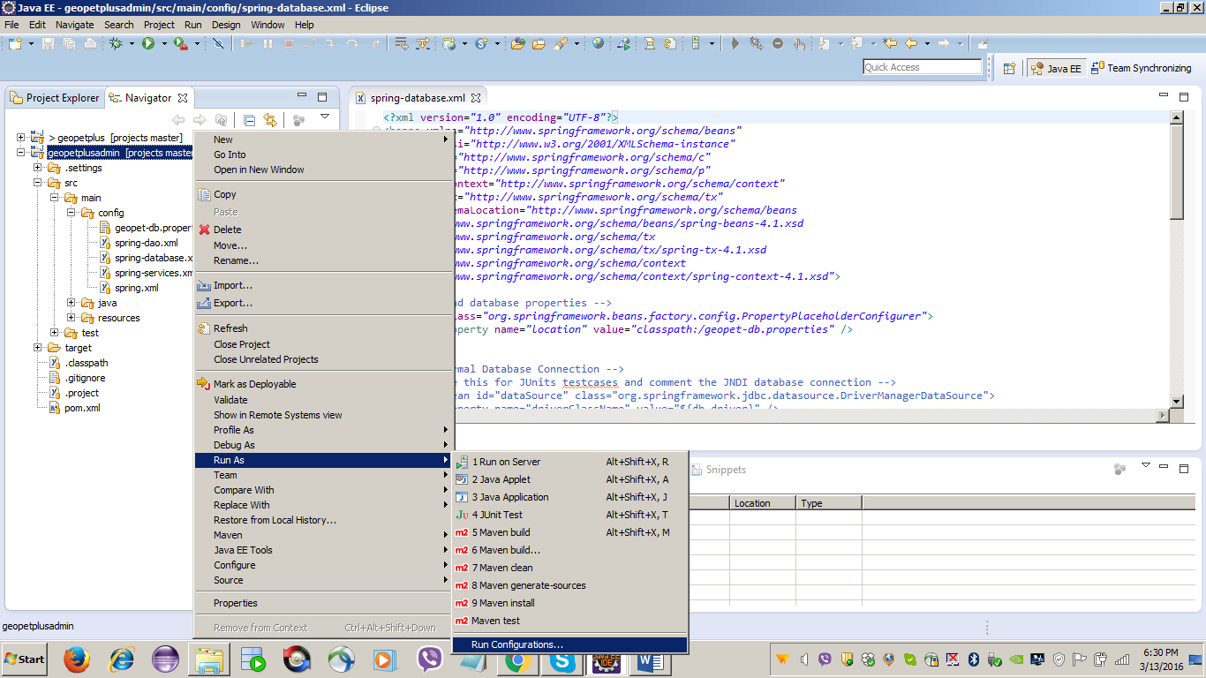

Step#: Run maven build
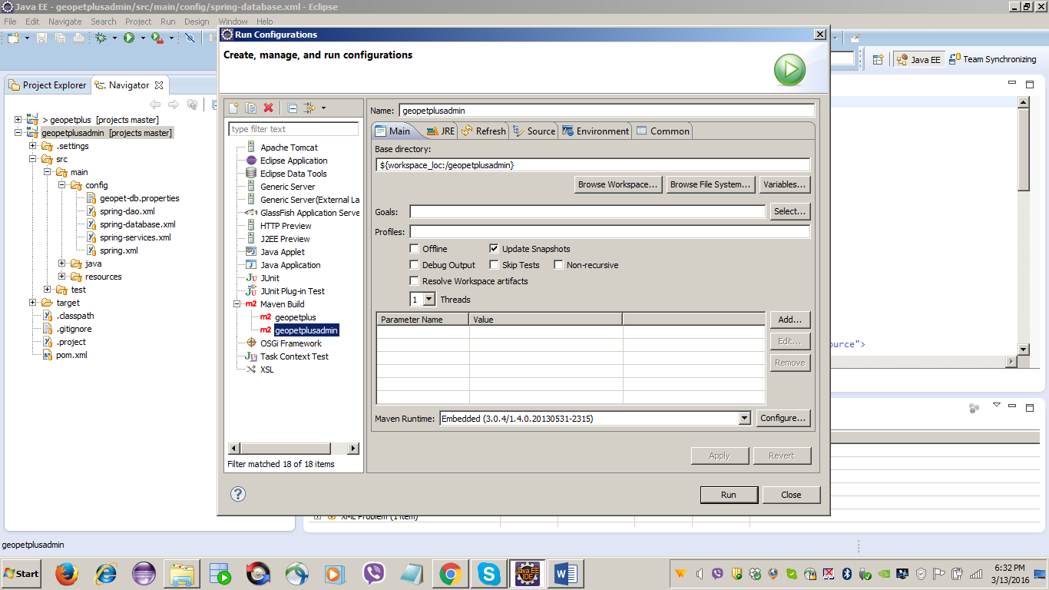

Step#: Update the maven project
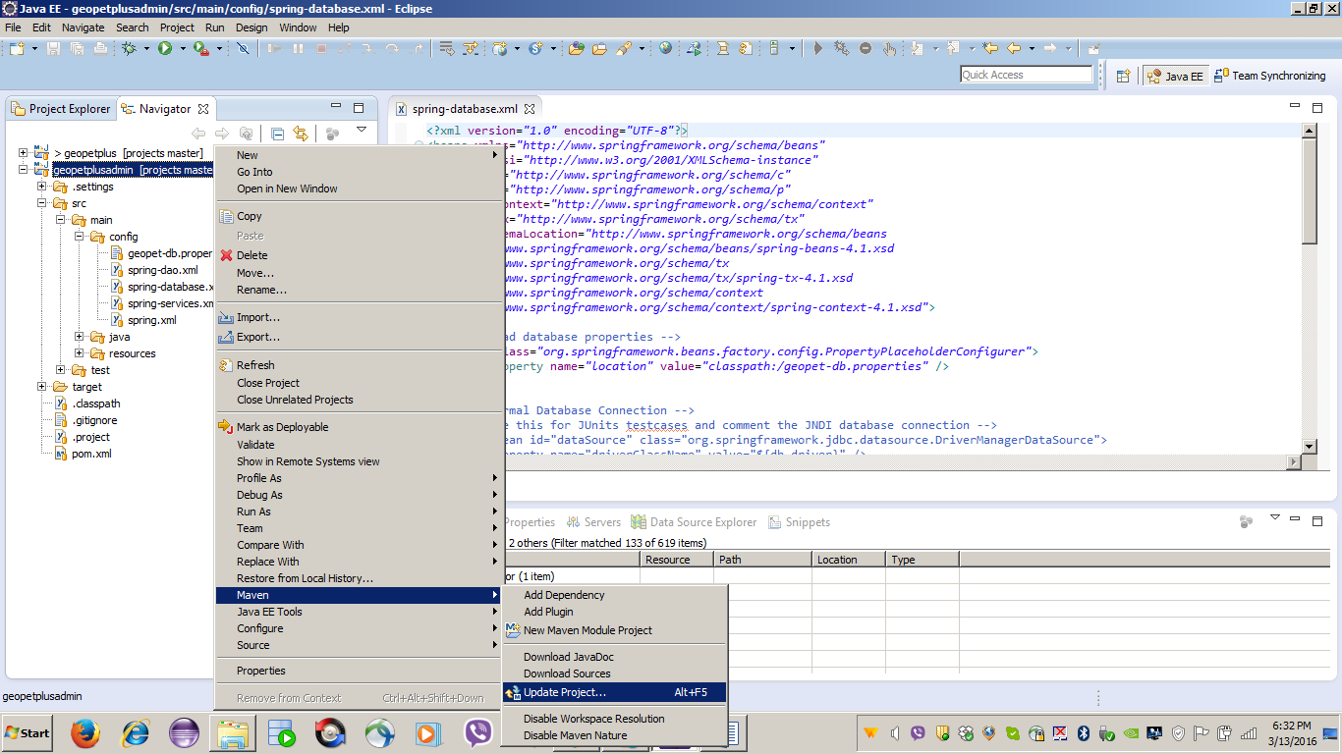

Step#:
- Go to geopetplus project
- Go to below project and copy context.xml
<< geopetplus project >>/guides/JNDI/context.xml
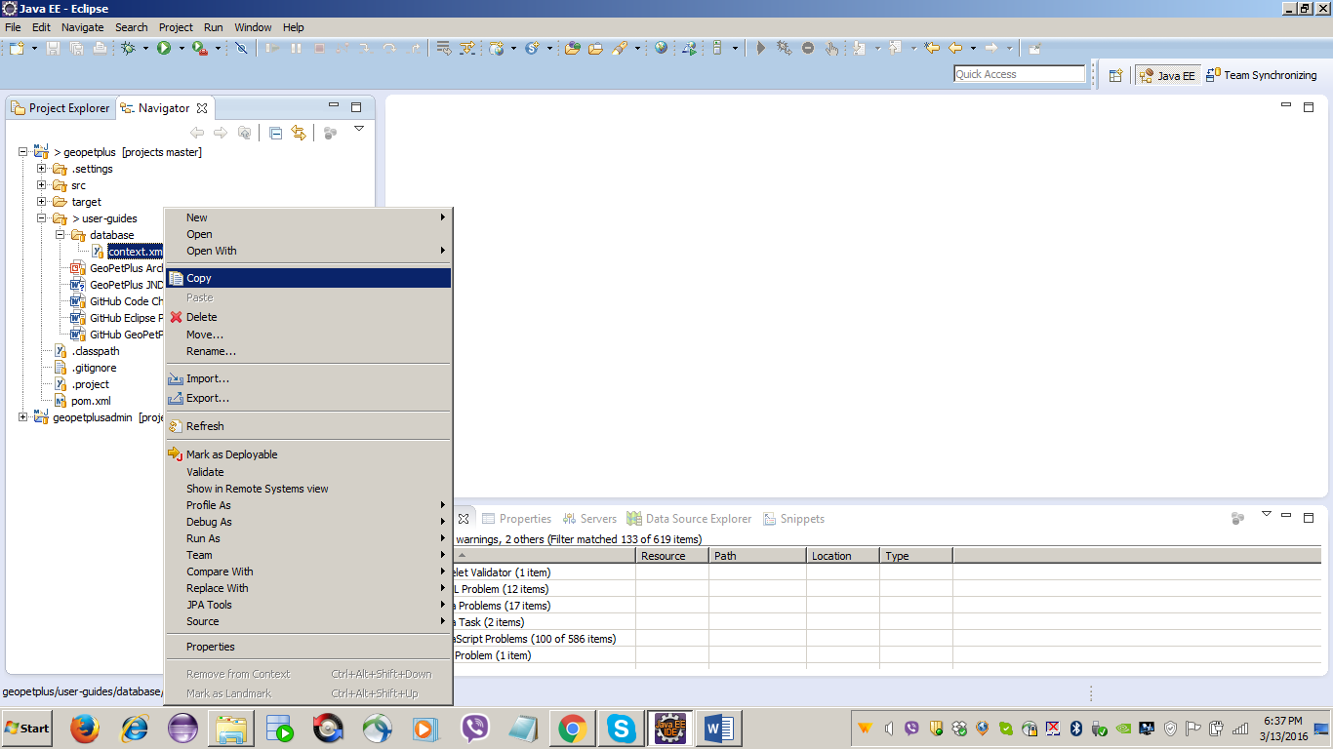
Step#: Paste the context.xml file into tomcat server folder
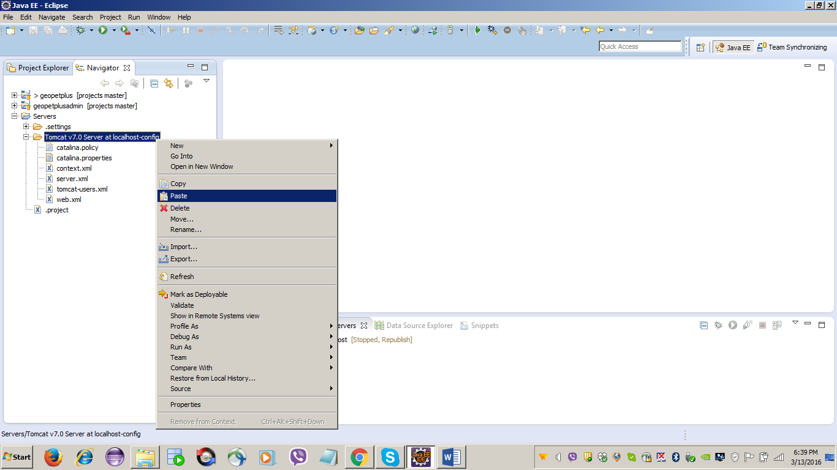

Happy Learning …!!

Thank You

